**TASK-6**

**Cosecant of angle.**

**EXPLANATION:**

The program takes angle in degrees and calculates value of cosecant and displays value as output, in degrees and radians.

**INPUT:**

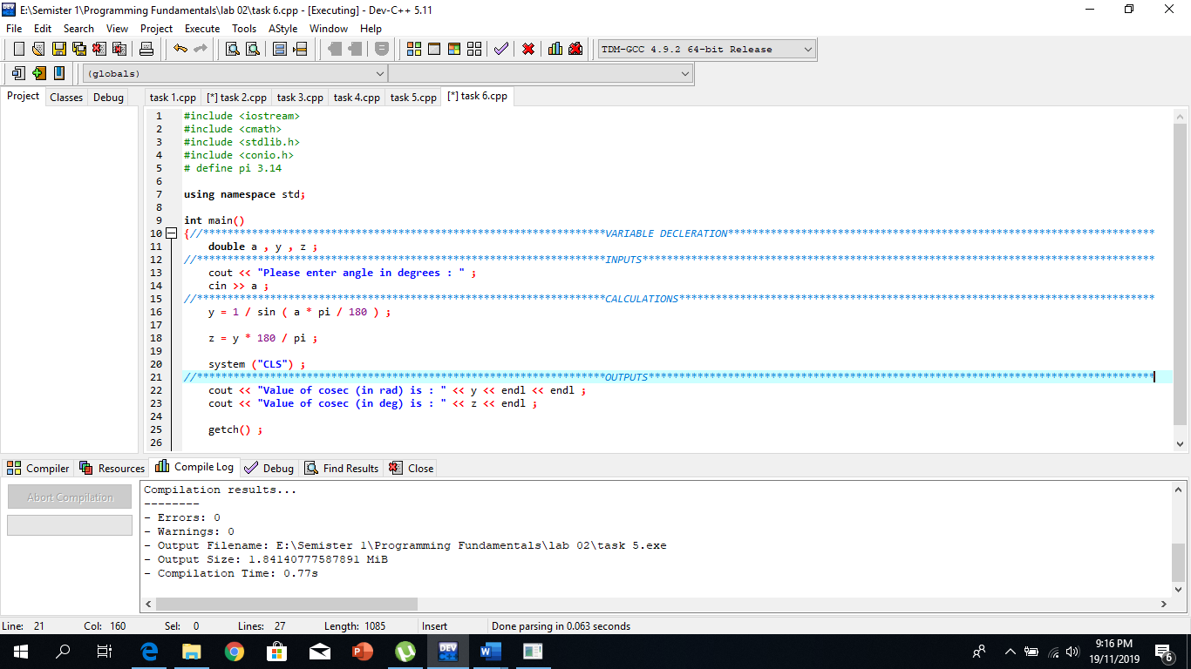

**OUTPUT:**

